<Project Name>
<Project Id>

High Level Design (OOAD)

Record of Release

Version No. | Modified By | Reviewed By | Authorized By | Release Date | Modifications Done
<Ver.> | <Full Name> | <Full Name> | <Full Name> | <Release Date>

Table of Contents
1.0 Introduction & Brief Description 3
2.0 References 3
3.0 Architectural Representation 3
4.0 Architectural Goals and Constraints 3
5.0 Use-Case View 3
5.1 Architecturally-Significant Use Cases 3
6.0 Logical View 4
6.1 Architecturally-Significant Model Elements 5
6.2 Architecture Overview – Package and Subsystem Layering 5
7.0 Process View 6
7.1 <ClassDiagram.Name> 6
8.0 Implementation View 6
9.0 Deployment View 7
9.1 <Node.Name> 7
10.0 Size and Performance 7
11.0 Quality 7
12.0 Annexure 8
12.1 Architecturally-significant Use Cases 8
12.2 Class Diagram 10
12.3 Deployment Diagram 11
12.4 Component Diagram 12

Introduction & Brief Description

< Include here a brief description of the role and purpose of the software design document. >

References
<Include a description of related or referenced documents>

Architectural Representation
<Include a description of what the software architecture is for the current system, and how it is represented. The representation description discusses how the architecture and the design are represented, the modeling conventions and artifacts used to present the information>

Architectural Goals and Constraints
<Include here a description of the software requirements and objectives that have significant impact on the architecture>

Use-Case View
<A description of the use-case view of the software architecture. The Use Case View is important input to the selection of the set of scenarios and/or use cases that are the focus of iteration. It describes the set of scenarios and/or use cases that represent some significant, central functionality. It also describes the set of scenarios and/or use cases that have substantial architectural coverage (that exercise many architectural elements) or that stress of illustrate a specific, delicate point of the architecture. >

<Model.UseCaseView.Documentation>

Architecturally-Significant Use Cases

Diagram Name: <SignificantDiagram.Name>

Click here for example

Diagram Documentation: <SignificantDiagram.Documentation>

<UseCase.Name>
Brief Description: <UseCase.Documentation>

Use-Case Realization <Use Case Realization.Name>
<UseCaseRealization.Documentation>

Diagram Name: <InteractionDiagram.Name>
Diagram Documentation: <InteractionDiagram.Documentation>

Use-Case Realization <UseCaseRealization.Name>
<UseCaseRealization.Documentation>

Diagram Name: <InteractionDiagram.Name>

Diagram Documentation: <InteractionDiagram.Documentation>

Logical View
< A description of the logical view of the architecture. Describes the most important classes, their organization in service packages and subsystems, and the organization of these subsystems into layers. Also describes the most important use-case realizations, for example, the dynamic aspects of the architecture. Class diagrams may be included to illustrate the relationships between architecturally significant classes, subsystems, packages and layers. >

<Model.LogicalView.Documentation>

Architecturally-Significant Model Elements

Diagram Documentation: <SignificantClassDiagram.Documentation>
Click here for Example

<Class.Name>

<Class.stereotype>
<Class.documentation>

<Packages.Name>
<Packages.stereotype>
<Packages.documentation>

Architecture Overview – Package and Subsystem Layering
<LayeringClassDiagram.Documentation>

Click here for Example

<Class.Name>
Class Name | Description
<Class.stereotype> | <Class.documentation>

<Packages.Name>
Package Name | Description
<Packages.stereotype> | <Package.Documentation>

Process View
< A description of the process view of the architecture. Describes the tasks (processes and threads) involved in the system's execution, their interactions and configurations. Also describes the allocation of objects and classes to tasks. >

<ProcessModel.Documentation>

<ClassDiagram.Name>

Click here for Example

Diagram Name: <ClassDiagram.Name>
<ClassDiagram.Documentation>

<ProcessElement.Name>
<ProcessElement.Documentation>

Implementation View
<ImplementationModel.Documentation>

Diagram Name: <ComponentDiagram.Name>
<ComponentDiagram.Documentation>
Click here for Example
- Packages Allocated to <ImplementationModel.Name>

Name | Description
<Package.Name> | <Package.Documentation>

- <ImplementationModel.Name> Module/Class Allocation

Module | Allocated Classes
<Component.Name> | <Class.Name> in <Class.ParentPackage.Name>

Deployment View
<A description of the deployment view of the architecture describes the various physical nodes for the most typical platform configurations. Also describes the allocation of tasks (from the Process View) to the physical nodes.
This section is organized by physical network configuration; a deployment diagram, followed by a mapping of processes to each processor illustrates each such configuration. >

Diagram Name: <Model.DeploymentDiagram.Name>
Diagram Documentation: <Model.DeploymentDiagram.Documentation>
Click here for Example

<Node.Name>
<Node.Documentation>

Size and Performance
- <Include here a description of the major dimensioning characteristics of the software that affects the architecture, as well as the target performance constraints>

Quality
- <Include here a description of how the software architecture contributes to all capabilities (other than functionality) of the system: extensibility, reliability, portability, and so on>

Annexure

Architecturally-significant Use Cases

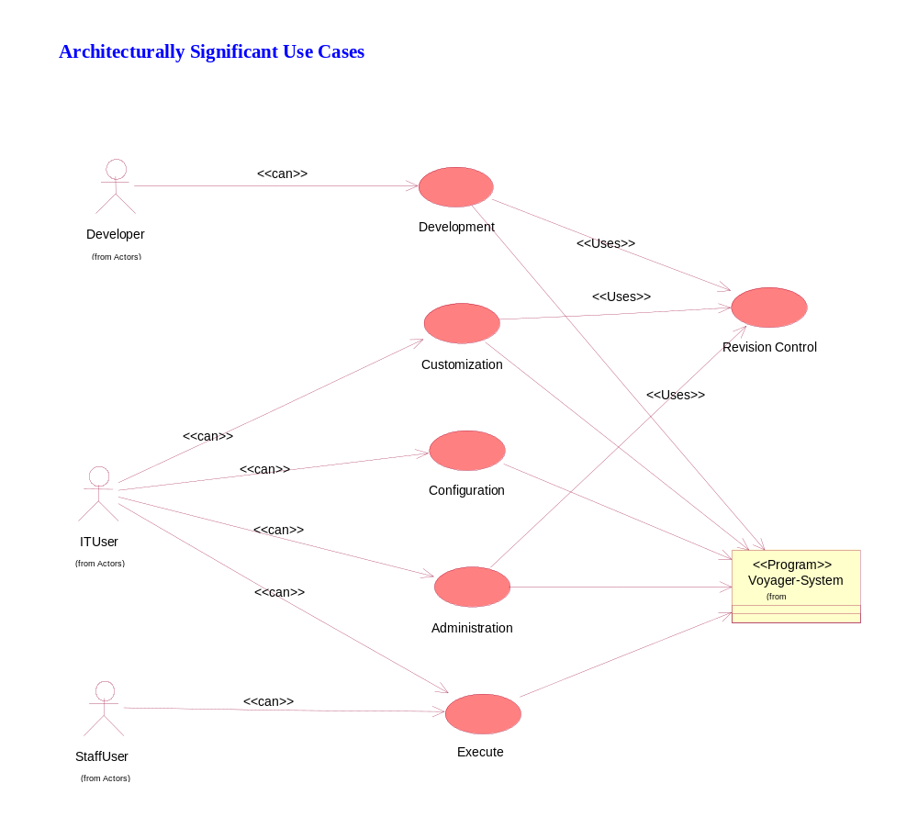
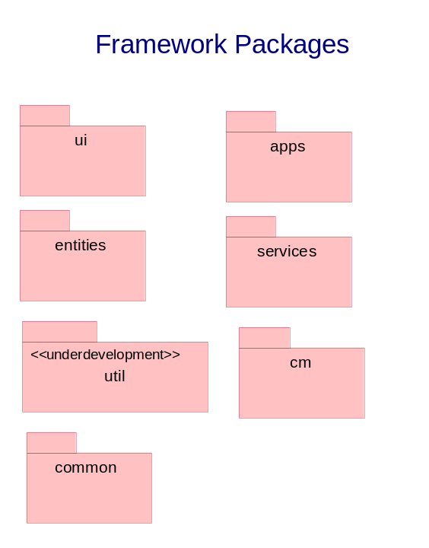

Class Diagram

The following is the class diagram for screen-related classes and their interaction with the application classes

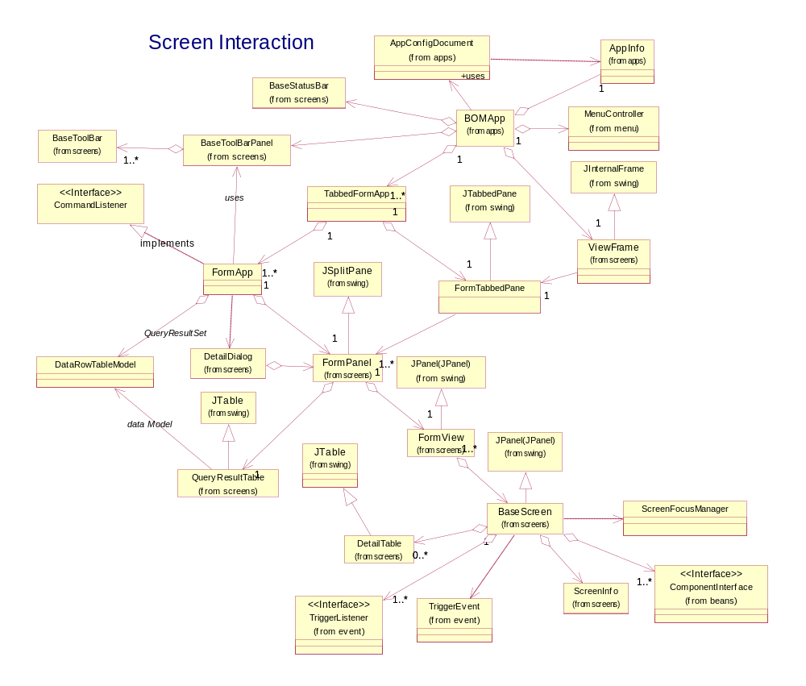

Deployment Diagram

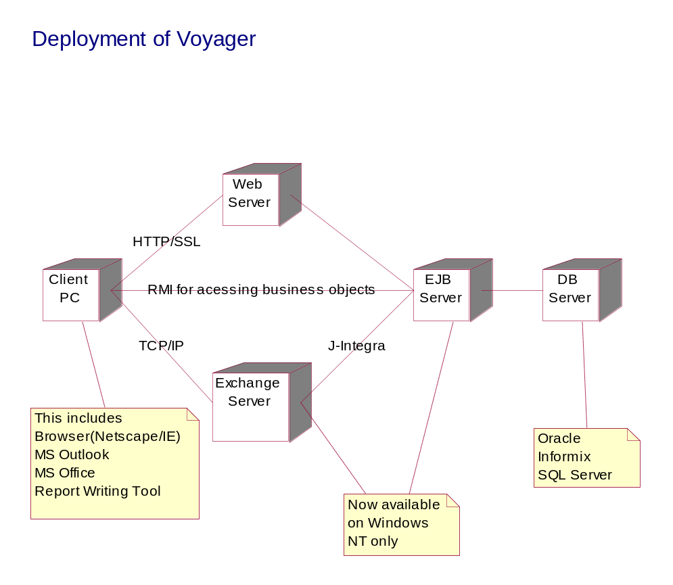

Component Diagram

